

LICENSURE EXAMINATION FOR PROFESSIONAL TEACHERS
SEPTEMBER 20, 2026

GURONG PINOY: PROFESSIONAL EDUCATION REVIEWER
(Session 11: May 22, 2026)

1. An assessment that uses the same or similar questions and is evaluated using the same criteria for all test-takers is referred to as a _____ assessment.
- standardized
- summative
- proctored
- formative

Note:
- STANDARD: same for everyone
- SUMMATIVE: after instruction
- PROCTORED: supervised
- FORMATIVE: during instruction

2. A raw score represents the _____.
- number of items on an assessment answered correctly
- number of items on an assessment answered incorrectly
- percent of items on an assessment answered incorrectly
- percent of items on an assessment answered correctly

3. A percentile rank of 60 indicates that _____.
- a student has gotten 60% of the test items correct
- a student has scored worse than 60% of his or her peers
- a student has scored better than 60% of his or her peers
- a student has gotten 60% of the test items incorrect

Note: PERCENTILE RANK: compares your performance with others.

4. The first time Joe complimented his grandmother, she smiled and gave him a hug, a consequence he enjoyed. He learned that every time he is nice to his grandmother, she rewards him in a similar way. Now, he's more likely to be nice every time he sees his grandmother, due to this anticipated reward. What kind of learning did Joe use in this example?
- Classical Conditioning
- Cognitive
- Observational
- Operant Conditioning

Note:
CLASSICAL CONDITIONING  Ivan Pavlov        (stimulus-response/ bell) | THEORY OF COGNITIVE DEVELOPMENT  Jean Piaget  (thinking processes)  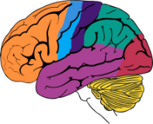    
OBSERVATIONAL LEARNING  Albert Bandura  (learning by watching)  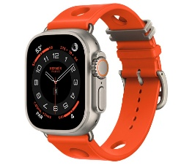     | OPERANT CONDITIONING  B.F. Skinner  (punishment and reward)  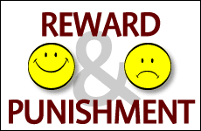    

5. The actions that cause harm toward others are known as _____ transgressions, while the actions that violate a culture's social norms are known as _____ transgressions.
- conventional; moral
- moral; conventional
- moral; cultural
- conventional; cultural

Note:
MORAL TRANSGRESSION | harm others (masakit)  Example: stealing, hitting
CONVENTIONAL TRANSGRESSION | break social rules (culture/customs)  Example: not wearing uniform

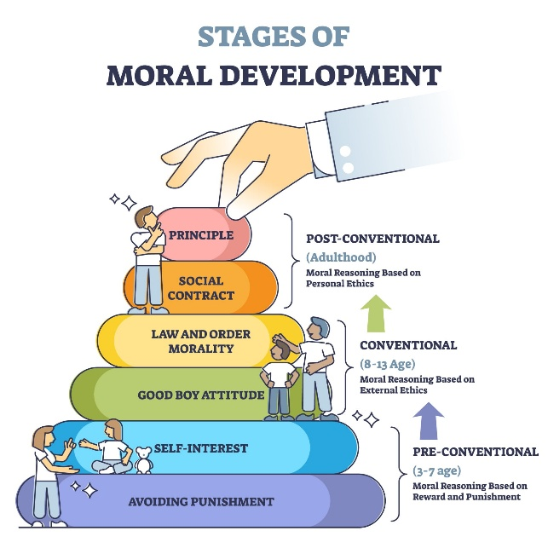
6. A child who shares her lunch snack with a classmate she wants to make friends with is in _____ of moral development
- the second conventional stage (stage four)
- the first conventional stage (stage three)
- the first post-conventional stage (stage five)
- the first pre-conventional stage (stage one)

STAGES OF MORAL DEVELOPMENT
Lawrence Kohlberg

(pre-conventional, conventional (good boy and law), post-conventional)



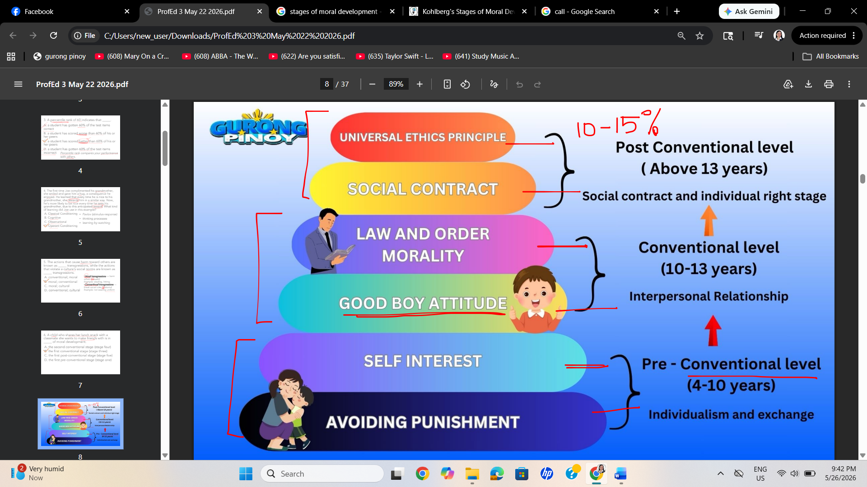

7. The client-centered therapy, developed by Carl Rogers is defined as _____.
- a counseling approach that requires the client to make a draft of the treatment plan
- a counseling approach that requires the client to take an active role in his or her treatment
- a counseling approach where the therapist will try a new theory on the client
- a counseling approach where the therapist is in charge of all the aspects of the treatment

Note:



CLIENT-CENTERED THERAPY
Carl Rogers
(client to take an active role in his or her treatment)

8. Which equation below is the correct one to calculate IQ scores?
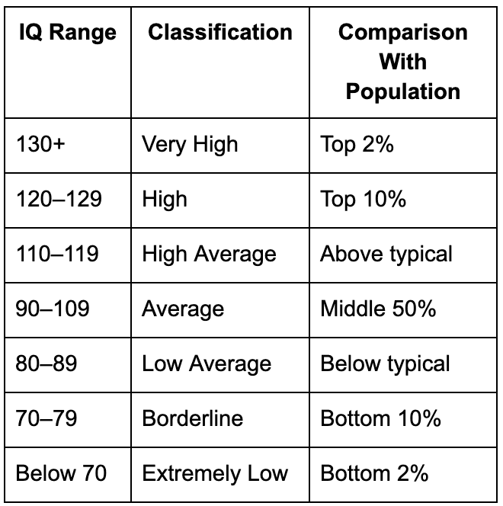
- (Fluid intelligence/Crystallized intelligence) X 7.50
- (Mental age/Chronological age) X 50
- (Mental age/Chronological age) X 100
- (Chronological age/Mental age) X 50

Note: Example
- Mental age = 12
- Chronological age = 10
- IQ = (12/10)100 = 1.2 x 100
- IQ = 120

9. Which of the tasks below makes the most use of crystallized intelligence as opposed to fluid intelligence?
- Learning the street names in a new city
- Applying literary theory to a first-edition novel, just printed
- Identifying clues at a crime scene and putting them together
- Memorizing the state capitals in the USA

Note:
- CRYSTALLIZED INTELLIGENCE: stored knowledge (collected)
- FLUID INTELLIGENCE: solving new problems

10. A politician who excels at remembering names, fostering cooperation and inspiring those around him exhibits _____.
- intrapersonal intelligence
- interpersonal intelligence
- linguistic intelligence
- logical intelligence

Note: INTERpersonal = INTERacting with people

11. A master chess player employs _____.
- logical intelligence
- intrapersonal intelligence
- visual intelligence
- interpersonal intelligence

12. Sasha gets a low grade on her math homework. Normally, her parents would take away her allowance and explain why math is important. However, on this occasion, they listen when Sasha explains that she was distracted because she was ill, so they decide not to punish her. What kind of parenting style is this?
- Mixed modeling
- Authoritative
- Neglecting
- Indulgent

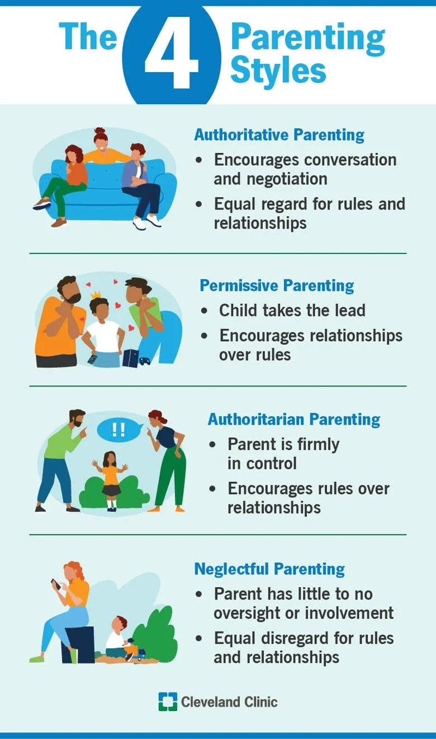




13. Anita gets all Ds and Fs on her report card. Her parents don't seem to care and tend to avoid spending time with her. They give Anita neither positive nor negative attention. What kind of parenting style is this?
- Mixed modeling
- Authoritative
- Authoritarian
- Neglecting

14. Which of the following would NOT address safety needs in the classroom?
- Hall monitors
- Limits/rules
- Colorfully decorated classroom
- Structure and daily routines

15. What is the first and most important need highlighted in Maslow's Hierarchy of Needs?
- Safety needs
- Social (love/belonging) needs
- Esteem needs
- Physiological needs
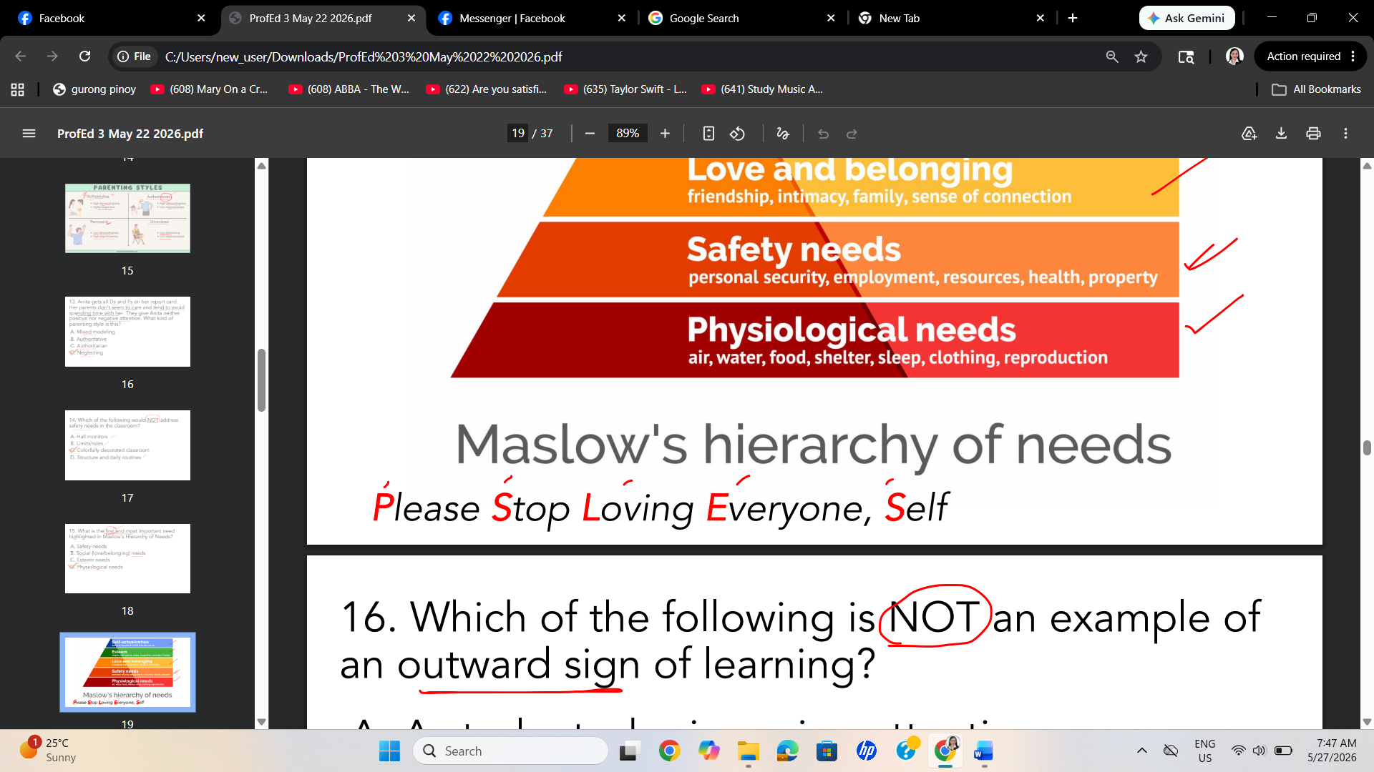
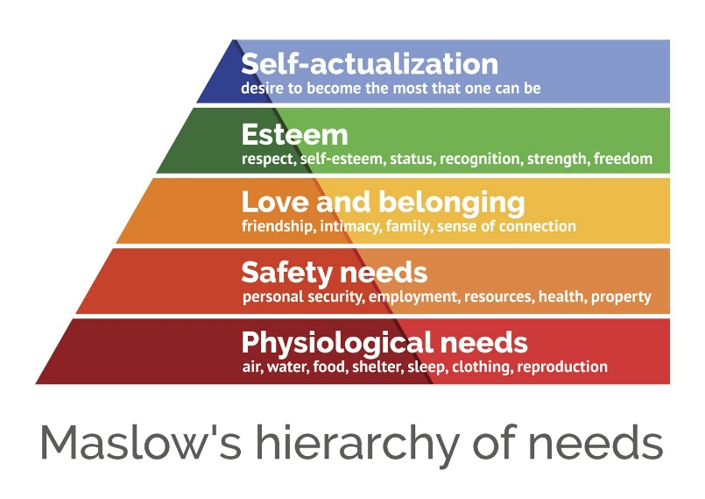
HIERARCHY OF NEEDS
Abraham Maslow
(Categories of needs like physiological,
Love and belongingness…
self-actualization)

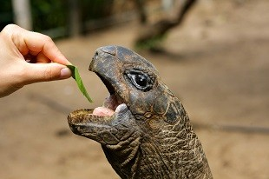


16. Which of the following is NOT an example of an outward sign of learning?
- A student who is paying attention
- A student who is staring at the floor
- A student nodding her head
- A student whose eyes light up

17. Which of the following statements would Urie Bronfenbrenner agree with?
- A person's parents are the only things that influence their development.
- A person's development is affected by everything in the surrounding environment.
- A parent's workplace is part of a child's macrosystem.
- The economy and political system are part of a child's microsystem.
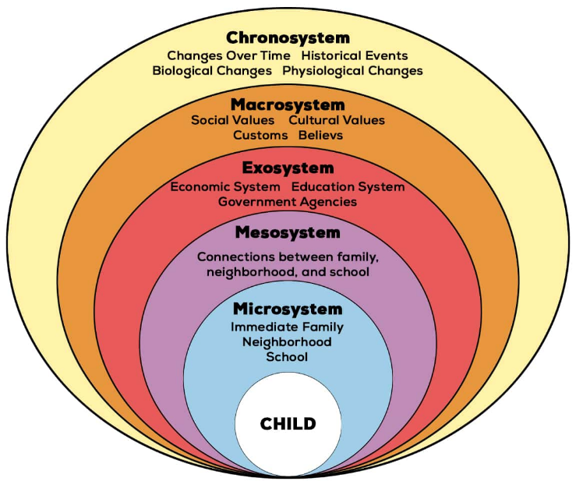
ECOLOGICAL SYSTEMS THEORY
Urie Bronfenbrenner
(development is affected by the environment)






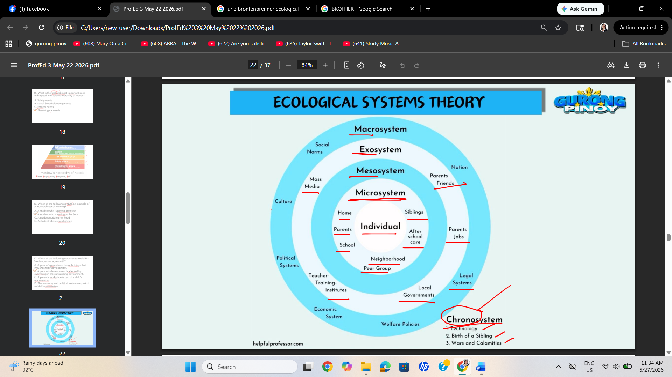

18. Knowing that someone grew up before TVs existed is an example of understanding someone based on their _____.
- chronosystem
- mesosystem
- macrosystem
- exosystem

19. The level that includes the interactions between the different microsystems in a person's life is the _____.
- mesosystem
- macrosystem
- chronosystem
- exosystem

20. The process of incorporating new information into existing knowledge is known as _____, whereas the process of adjusting our schemas to fit new information and events is known as _____.
- organization; assimilation
- assimilation; accommodation
- accommodation; assimilation
- schema, accommodation

Note:
- ASSIMILATE: same schema
- ACCOMMODATE: change in schema

21. Jose is in a casino. He sees his friends Amy and Sandra win money at a nearby slot machine. Amy and Sandra cheer and clap. Jose wants to feel the same excitement, so he sits down at a slot machine and begins to gamble. This is an example of _____.
- vicarious reinforcement
- environmental interaction
- positive behavior
- performance phobia

Note: VICARIOUS: Viewing others

22. Erikson's developmental stage of industry vs. inferiority can be compared to which of Freud's psychosexual stages?
- Phallic
- Latency
- Oral
- Anal


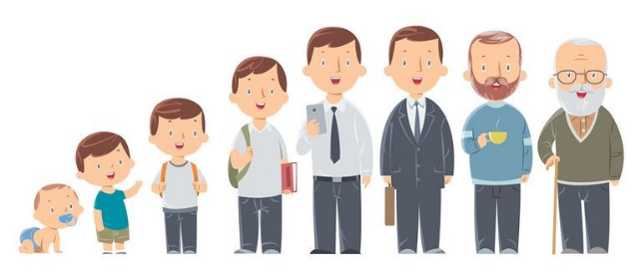
PSYCHOSOCIAL DEVELOPMENT
Erik Erikson
(Eight distinct stages of human growth
from infancy through late adulthood)




PSYCHOSEXUAL DEVELOPMENT
Sigmund Freud
(The libido zones)

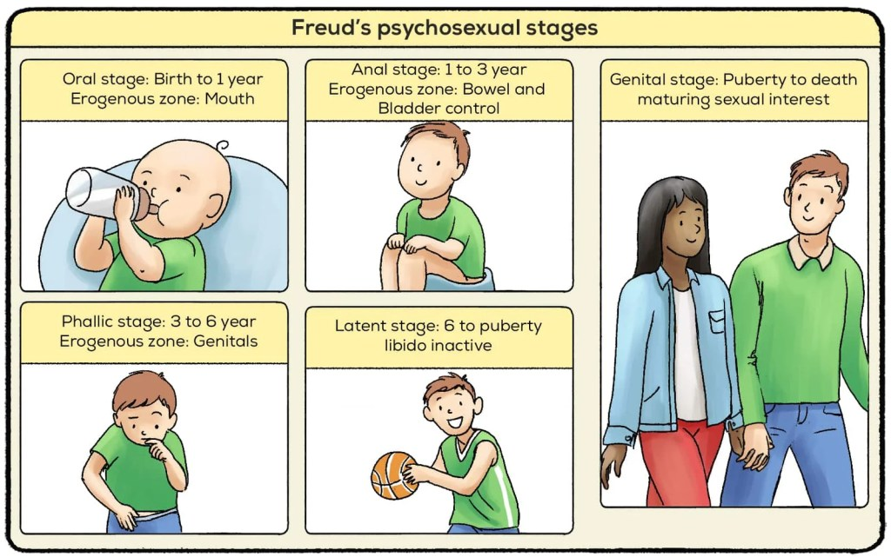
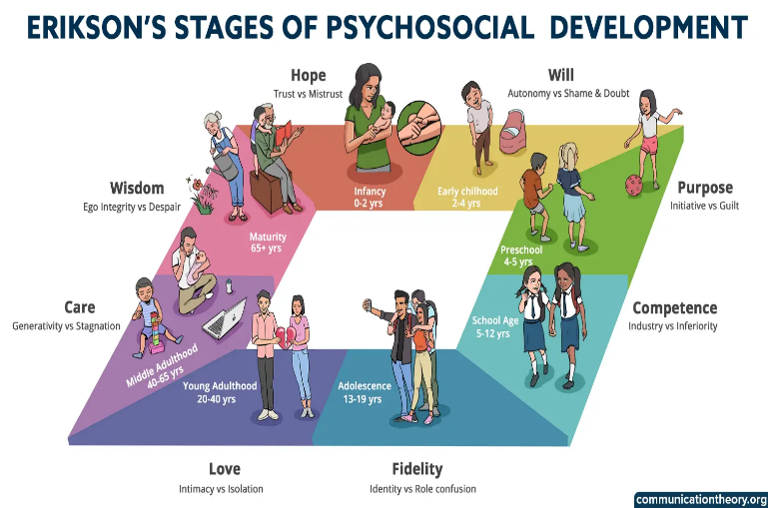

Note:
ERIKSON (MSG IRIS SD)  - Mistrust: Infant HOPE  - Shame & Doubt: Toddler WILL  - Guilt: Pre-schooler PURPOSE  - Inferiority: Grade-schooler COMPETENCE  - Role confusion: Teenager FIDELITY  - Isolation: Young adult LOVE  - Stagnation: Middle-aged adult CARE  - Despair: Older adult WISDOM | FREUD (OA PHALAGE) “OA Palagi”  - Oral: mouth  - Anal: bowel and bladder control  - Phallic: Genitals (pepe and titi)  - Latent: Libido is inactive  - Genital: Sexual interest with partner

23. Mark is taking a high-stakes university exam and is sitting next to the smartest student in the class. Mark can clearly see his classmate's responses but refrains from copying the answers. Which of the following is affecting Mark's behavior?
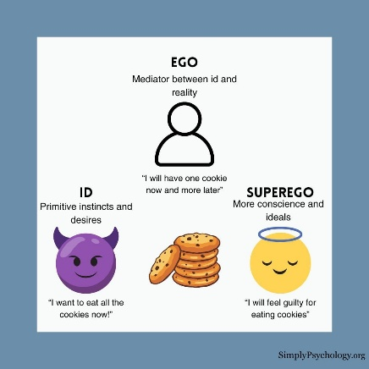
- Ego
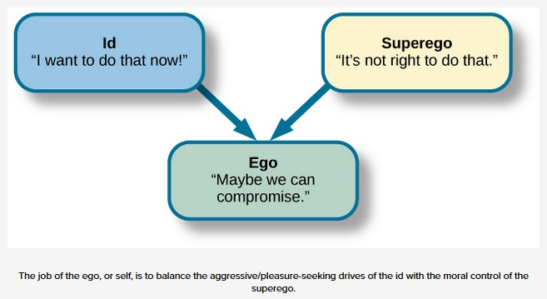
- Instinct
- Id
- Superego

24. The digital generation refers to which one of the following?
- Students who are connected to the world through their digital devices
- Generations of digital devices, ranging from televisions to smartphones
- Anyone born after the introduction of digital technology
- Students who can only learn through the use of digital devices

25. Ms. Greenberg realizes that one of her students has been misbehaving in class to get the attention from her. Ms. Greenberg decides to simply ignore the behavior until the student stops associating the behavior with the reward her attention. Which technique is used in this example?
  - Extinction
  - Time Out
  - Satiation
  - Corporal Punishment

Note:
- TIME OUT: removal from activity
- SATIATION: overexposure
- CORPORAL PUNISHMENT: physical punishment

26. Before learning about differentiated instruction, students were asked to guess the meaning of the term. The teacher received these four responses. Analyze these responses and indicate which one best aligns with the concept of differentiated instruction.
- Differentiating instruction means you provide students with different options for demonstrating what they have learned.
- Differentiating instruction means you develop a different lesson for each student to allow them to demonstrate what they have learned.
- Differentiating instruction means you give all students different amounts and different kinds of work most every day.
- Differentiating instruction means you assign more work at the same level to high-achieving students.

27. Which of the following demonstrates the teacher's integrity?
- Innovation
- Entrepreneurship
- Moral courage
- Decisive thinking

Note: INTEGRITY: doing RIGHT despite pressure

28. A qualitative research involves ___ data.
- numerical
- statistical
- categorical
- non-numerical

29. Giving of assignments, standards and procedures are part of this approach.
- Assertive Approach
- Group Managerial Approach
- Business Management Approach
- Behavior Modification Approach

Note:
- ASSERTIVE: teacher firmness
- GROUP MANAGERIAL: handling groups effectively
- BEHAVIOR MODIFICATION: reinforcement/punishment

30. The Philosophy of relating ideas to prior knowledge.
- Humanism
- Cognitivism
- Constructivism
- Metacognition

Note:
SOCIOCULTURAL THEORY  Lev Vygot(s)zky  (Individuals learn through social interactions, cultural tools, and language / ZPD)  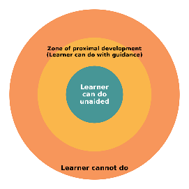     | METACOGNITION THEORY  John Flavell  (thinking about thinking)  